2024 SDCA SPRING CONFERENCE
“Better Together!”
April 25-27, 2024 Spearfish Holiday Inn Convention Center

Name:

Address:
^{Street/PO Box} ^{City} ^{State} ^{Zip}
Email:

PRE CONFERENCE REGISTRATION: Please note, SDSCA and SDMHCA are holding SEPARATE pre conference events this year. See page 2 & 3 for more information.
 | SDSCA See Page 2 (6 CEs) | SDMHCA See Page 3  (6 CEs)
Professional Member of SDSCA or SDMHCA | $60 | $60
Retired or Student Member of SDSCA or SDMHCA | $60 | $60
Non Member | $75 | $85

___________ Total

SDCA CONFERENCE REGISTRATION:
(Registration includes the Friday Area of Specialty Luncheon and the Friday Awards Banquet)

Annual Membership Dues: Our membership year runs annually. You MUST be a SDCA Member to register for the conference at the member price. See third page for membership information. (If you are unsure if your SDCA membership is current, contact SDCA.)
Professional Member of SDCA | All Conference  $250.00 | Friday Only  $175.00 | Sat Only  $110.00
Retired or Student Member of SDCA | $130.00 | $90.00 | $65.00
Non SDCA Member | $325.00 | $275.00 | $130.00
Group Rate | $1200.00 | $1000.00 | $600.00

Please indicate which luncheon you will be attending ______ SDSCA _______SDMHCA ______ I am not attending a luncheon
Will you be attending the Awards Banquet ______ Yes ______ No

Preconference Registration Fees
SDCA Conference Registration Fees
SDCA Membership Dues (if applicable-see second page for membership information)
Guest Meals (if applicable) $25 for Luncheon $35 for Banquet
Credit Card #:
Expiration Date: CVV:
Card Billing Address:

TOTAL: ____________
Please make checks payable to: SDCA (NO Purchase Orders Please). Complete this form and mail with payment to: SDCA, PO Box 38, Platte SD 57369
SDSCA Preconference Workshop

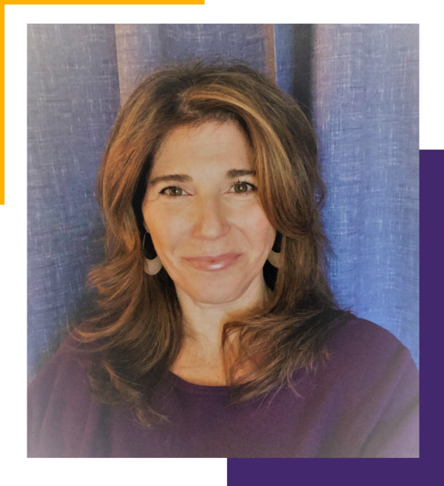

Creating Options for Growth by Preparing Brains and Bodies to Learn
presented by Judith Norman, MA, MS, LSC,LPC, RPT-S

Thursday, April 25, 2024
Time: 9:00 to 12:00 pm MT
12:00 to 1:00pm MT Lunch On Own
1:00 to 4:00pm MT
6.0 Contact Hours

Synopsis of Presentation: Does it ever feel like you’re doing all you can and not seeing the desired results? If so, you are not alone. Educators, school counselors, and clinical mental health professionals are all experiencing frustration and stress. Why? Students aren’t ready to learn, social-emotional programming is missing vital pieces, and many of our interventions inadvertently create escalation and are unsuccessful in shifting behavior.
Spend the day exploring solutions.
· Learn to recognize when students are not in brain or body states conducive to learning and what to do about it based on neuroscience.
· Learn to implement minor shifts in daily routines that support developing social-emotional wellness and self-regulation skills.
· Learn how to create options for new behaviors by understanding why a specific strategy might or might not work at that moment, facilitating the use of the right strategy at the right time.
Help expand windows of tolerance, which grows the capacity for dealing with stress and challenges for students and adults in and out of the classroom. Join us for a transformative day.
Cost:
SDSCA or SDMHCA Member- $60
SDSCA or SDMHCA Student or Retired Member- $60
Non-Member- $75

Speaker Information: Judith is an educator, trainer, coach, and clinical supervisor. She is a co-founder and the lead trainer at the Synergetic Education® Institute. She is licensed as both a Professional and a School Counselor and has worked at the intersection of education and mental health for over 20 years. Judith trains clinical and school-based mental health professionals and speaks and consults internationally on creating trauma- informed schools. As a District-Wide Social Emotional Learning Coach Judith led her school district in implementing a Kaiser Permanente “Thriving Schools Grant,” aimed at advancing social-emotional wellness and behavioral health in school districts Judith is a Registered Play Therapist Supervisor and is a Certified Synergetic Play Therapy® Supervisor and Teacher. She is a Parent Educator, Certified in EMDR Therapy, and is trained in Mindfulness in Education. She has been utilizing the tenets of Synergetic Play Therapy® in educational settings for the past 10 years. Her experience has led to the development of social-
emotional, trauma-informed programming to support students and educators in schools. Judith Founded the Braindrops Play Therapy Wellness Center where she synthesized trauma-informed practices with child clients, family education and support, along with Rhythmic Movement Training. In her words, “Co-Founding the Synergetic Education Institute is a coalescence of all that feels purposeful to me, I’m inspired to have the opportunity to share what I love.”

SDMHCA Preconference Event

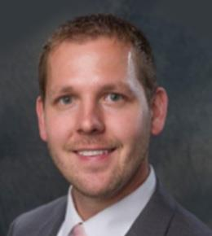

Clinical Issues in Human Sexuality in Professional Counseling
presented by Adam Hardy, PhD, LPC-MH, LAC, QMHP, NCC
Thursday, April 25, 2024
Time: 9:00 am to 12:00 Lunch Break 1:30pm to 4:30pm MT
6.0 Contact Hours ( Contact Hour Ethics)

Synopsis of Presentation: Nearly all humans are highly sexual beings and concerns about sexuality are common. Nonetheless, these topics often remain taboo and difficult for clients and counselors to navigate. The proposed program will be, in part, derived from non-published research data collected by the presenter. The presenter collected data on counselor self-efficacy to work with 31 specified client populations. The data indicates that counseling issues in human sexuality are among the lowest rated client populations. In other words, counselors are reporting that they are not confident in their aptitude to effectively work with sexuality issues when compared to other counseling issues.
Specifically, counselors rate low levels of self-efficacy to perform counseling with sexual dysfunction, sexual paraphilia, and sex offenders. The goals of the program will be to a) identify and discuss counselor self-efficacy to counsel specific client populations, b) discuss counseling clients with sexual dysfunction issues, c) discuss counseling clients with sexual paraphilia issues, and d) discuss counseling clients with convicted sex offenses. CACREP and ACA Code of Ethics standards are weak in terms of mandating training on these subjects. Those who attend will gain increased knowledge in areas critical to address in continued education. The presentation will include the following objectives:
- Learning objective one: Participants will be able to identify and discuss barriers to high levels of counselor self-efficacy while counseling issues related to sexuality
- Learning objective two: Participants will be able to articulate common therapeutic issues specific to working with clients who present with sexual dysfunction, sexual paraphilia, and criminal sex offenses.
- Learning Objective three: Participants will be able to identify typical and atypical human sexual behaviors across the lifespan
- Learning Objective four: Participants will practice assertive communication styles while discussing issues related to human sexuality
Cost:
SDSCA or SDMHCA Member- $60
SDSCA or SDMHCA Student or Retired Member- $60
Non-Member- $85
Speaker Information: Dr. Adam Hardy works as a full-time Assistant Professor with the University of South Dakota. Additionally, he is the owner of Sunstone Counseling, a mental health counseling private practice in Yankton, SD. He earned his Ph.D. in Counselor Education from the University of South Dakota in August 2017. He has worked as a licensed professional counselor since 2012, specializing in the domains of sexual assault, domestic violence, criminal rehabilitation, and substance use disorders. Dr. Hardy's teaching interests include diagnosis/treatment, traumatic stress and crisis counseling, group counseling, and clinical practicum supervision. Dr. Hardy's research interests include the following areas: human sexuality, substance use disorder treatment, traumatic stress, ethical practice in the field of counseling, and implementation of theory in counseling.
ANNUAL MEMBERSHIP DUES:
Our memberships run annually. If you are unsure if your SDCA membership is current, contact SDCA at sdca.counseling@gmail.com

SDCA Professional Member | $80
SDCA New Professional Member | $45
SDCA Retired Member | $30
SDCA Student Member | $30

Area of Specialty Membership
SD Mental Health Counseling Association (SDMHCA) | Professional- $30 | Retired/Student- $10
SD School Counseling Association (SDSCA) | Professional- $30 | Retired/Student- $10
SD Native American Counseling Association (SDNACA) | Professional- $20 | Retired/Student-$10

Chapter Memberships
Central Chapter (Pierre area) | Professional- $5 | Retired/Student- $5
Interlakes Chapter (Brookings area) | Professional- $5 | Retired/Student- $5
Lewis & Clark Chapter (Vermillion/Yankton area) | Professional- $10 | Retired/Student- $5
North Central Chapter (Aberdeen area) | Professional- $10 | Retired/Student- $5
Palace/Pheasant Chapter (Mitchell/Huron area) | Professional- $10 | Retired/Student- $5
Sioux Chapter (Sioux Falls area) | Professional- $10 | Retired/Student- $5
West River Chapter (Rapid City area) | Professional- $10 | Retired/Student- $5
__________Total

LODGING INFORMATION
SDCA has reserved a block of rooms at the Spearfish Holiday Inn Convention Center at the rate of $99.99 standard room per night or $129.99 suite room per night. Make your reservations directly with the Spearfish Holiday Inn Convention Center at 605-642-4683. Guests must specify they are with the South Dakota Counseling Association to receive the group rate.
The hotel block will be released on March 31, 2024, and this rate cannot be guaranteed after that time.
Cancellation/Refund Policy for 2024 SDCA Conference:

Cancellation requests received prior to Feb 15, 2024 – Entire registration fee less 10% for processing.
- Cancellation requests received between Feb 15-March 15, 2024 – Entire registration fee less 20% for processing.
- NO REFUND for cancellations made after March 15, 2024.

Requests for cancellations and refunds must be made in writing by mail or email
Mail requests: SDCA PO Box 38 Platte SD 57369
Email requests: sdca.counseling@gmail.com
If your company/school paid your fees, the check will be sent back to them.

